**ANALYSIS REPORT ON FUEL PERFORMANCE:**

**Objective:**

The notebook aims to analyse fuel performance metrics using the relevant dataset. It is a regression data having 15 features and one dependent variable target3

**Steps Involved:**

**Data Loading:**

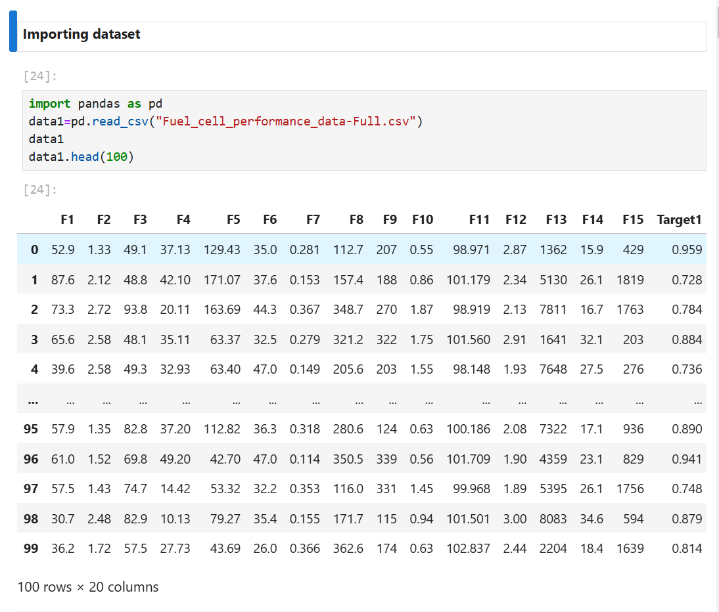

**Removing irrelevant target variables:**

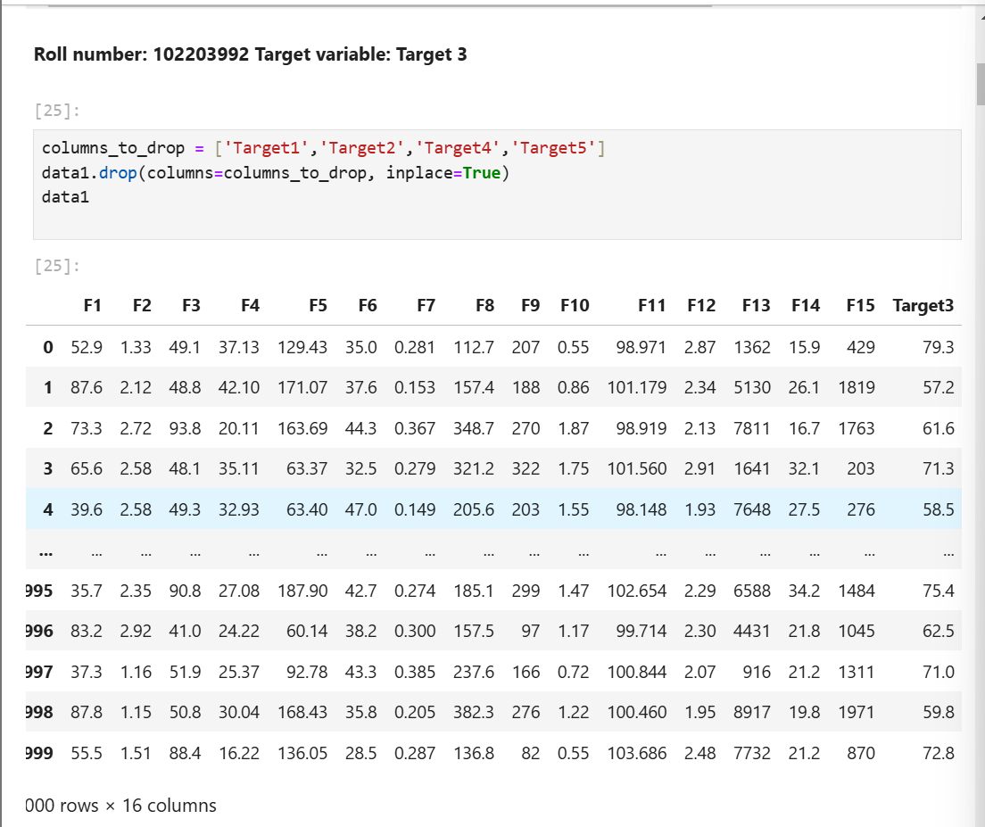

**Installing Pycaret and setting up data after splitting it into training and testing data in ratio 70:30-**

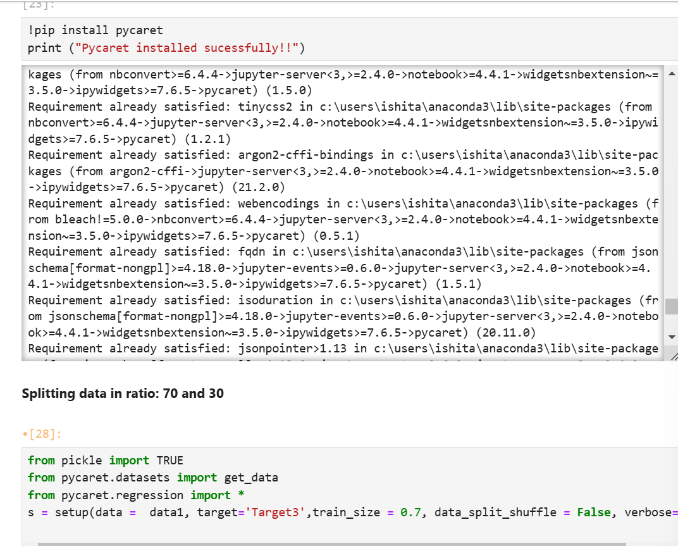

**Applying all predictive models without any preprocessing:**

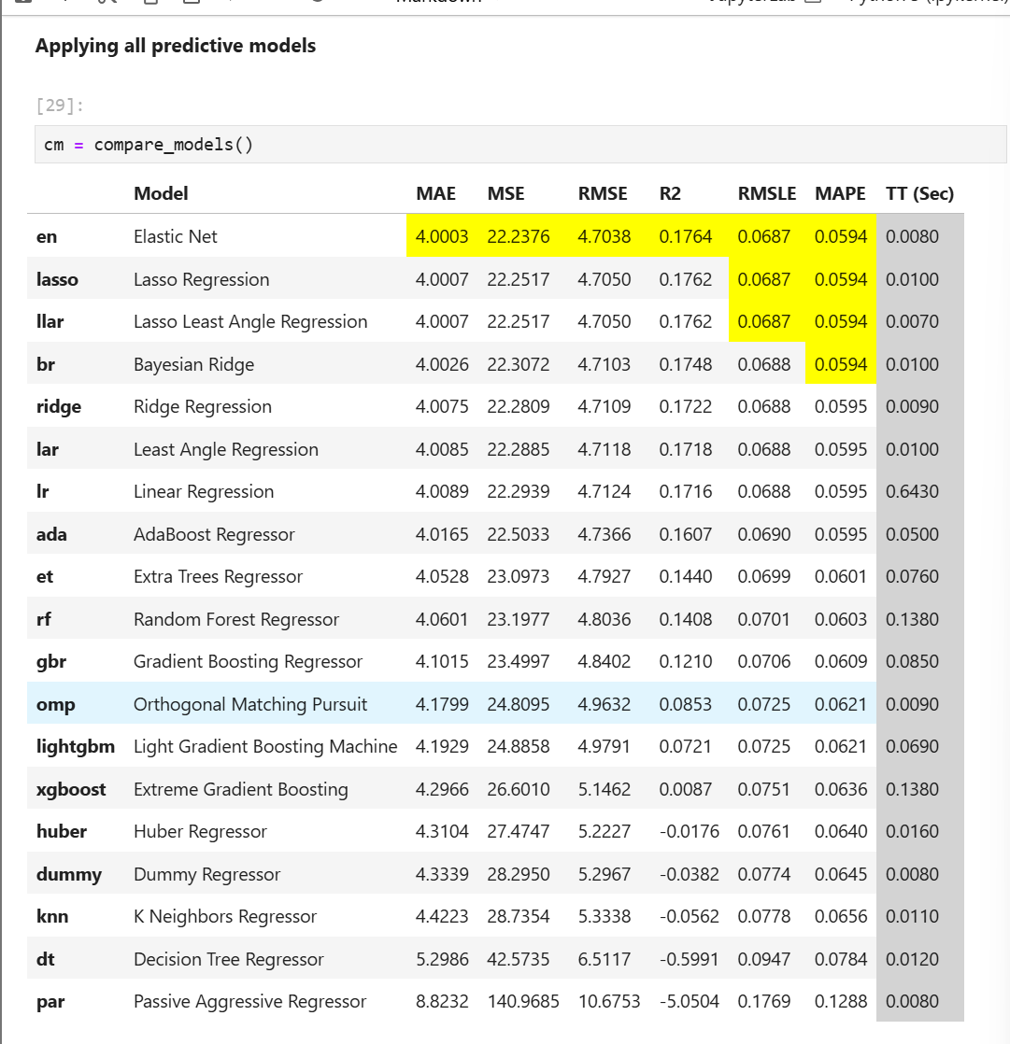

**Data Preprocessing:**

**Normalisation: we have applied normalisation techniques like zscore, minmax, maxabs and robust but highest R2 score is obtained by maxabs**

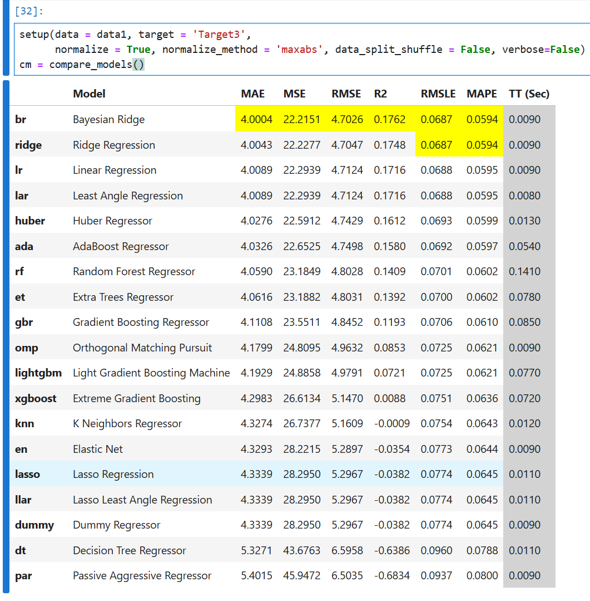

**Feature Selection:**

**We are getting maximum R2 score using Univariate mode**[**¶**](http://localhost:8888/notebooks/Fuel%20Performance-102203992.ipynb#We-are-getting-maximum-R2-score-using-Univariate-mode)

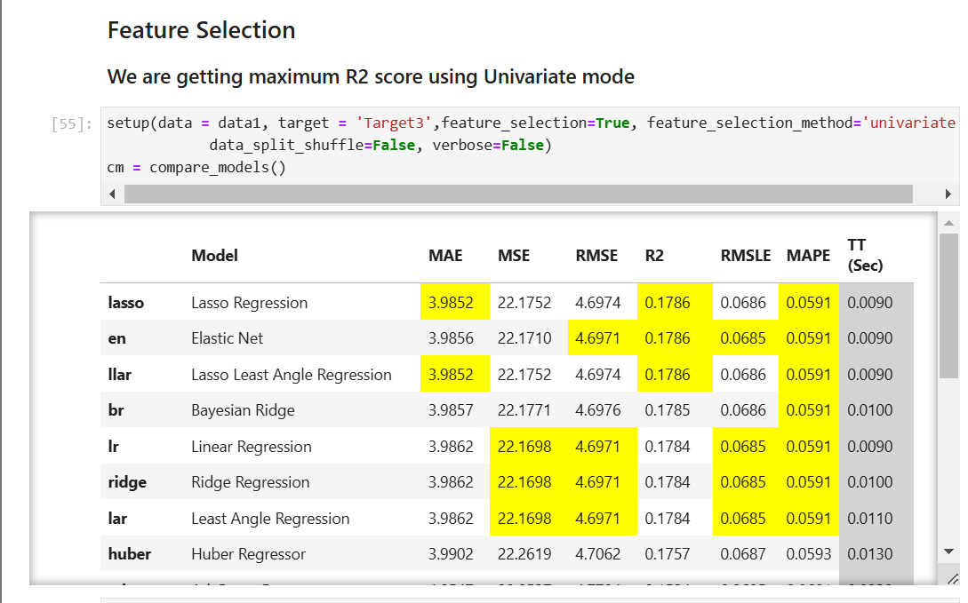

**Outliers Removal:**

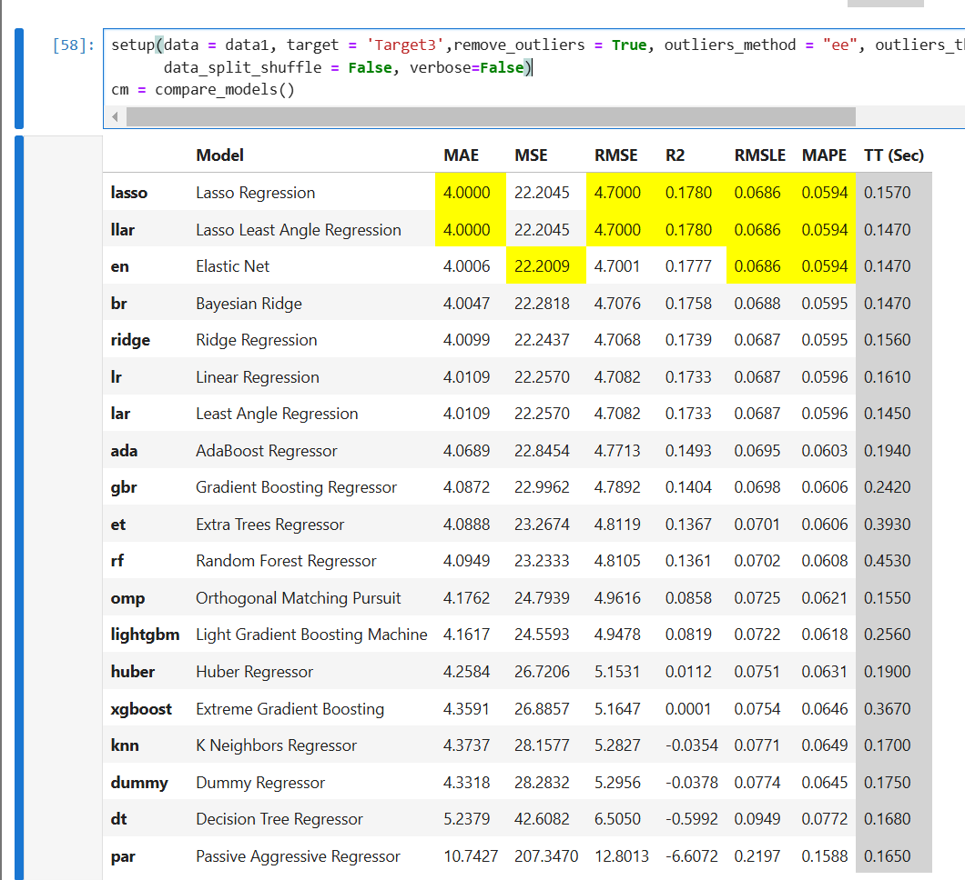

**Transformation:**

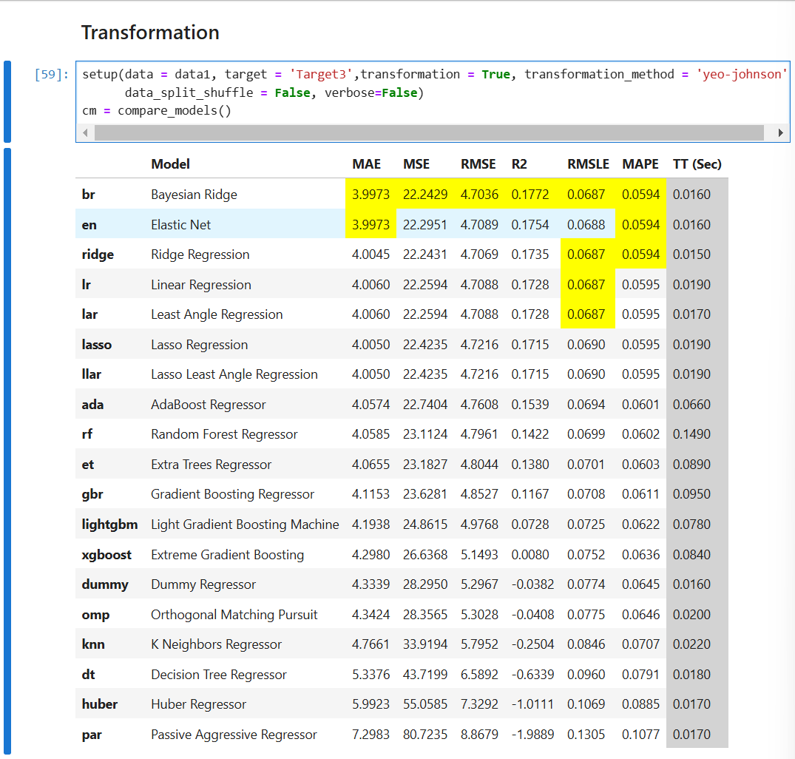

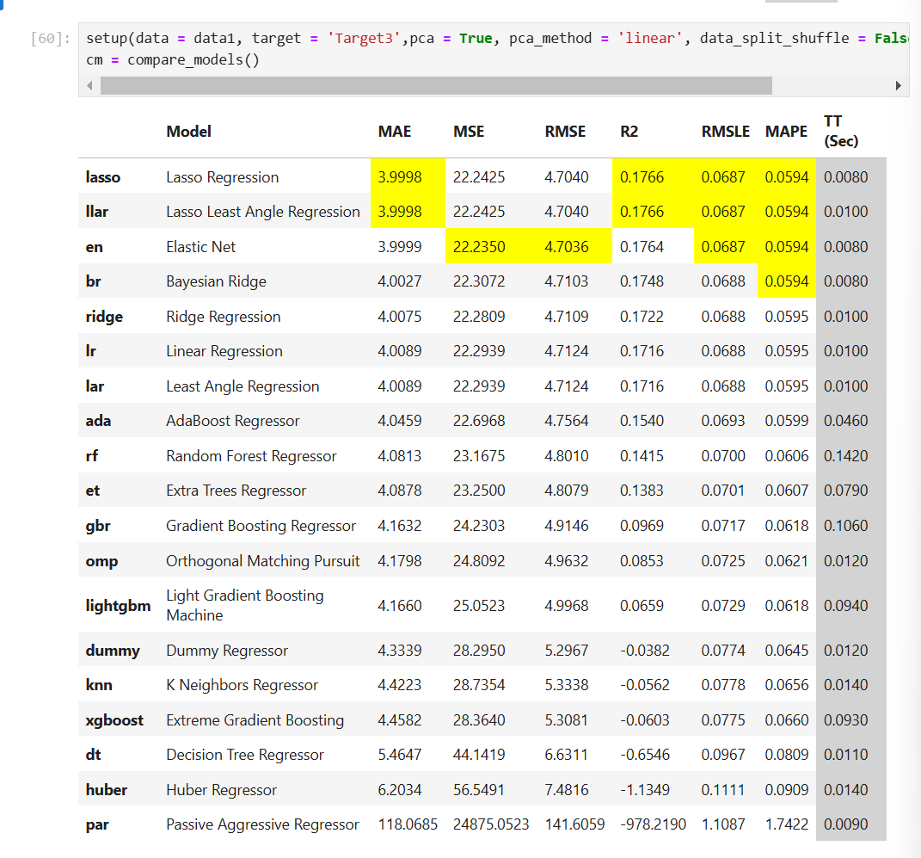

**Model performance using "Outlier Removal" + "Normalization" + "Transformation":**

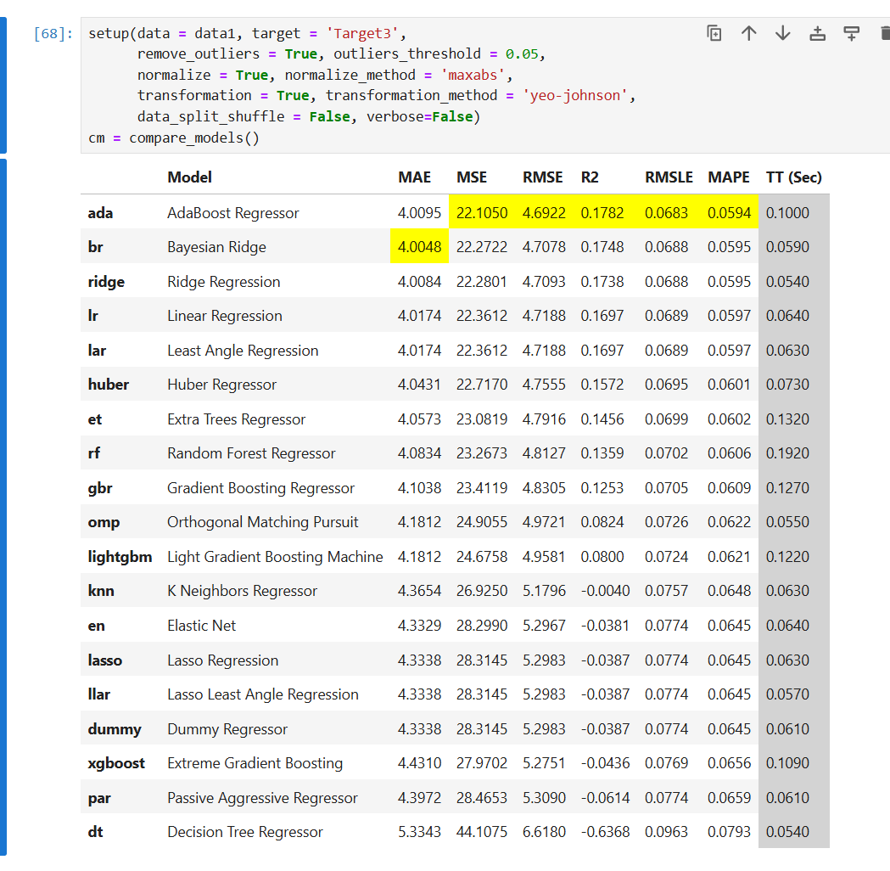

**Maximum r2 score is by ADABOOSTER Regressor:**

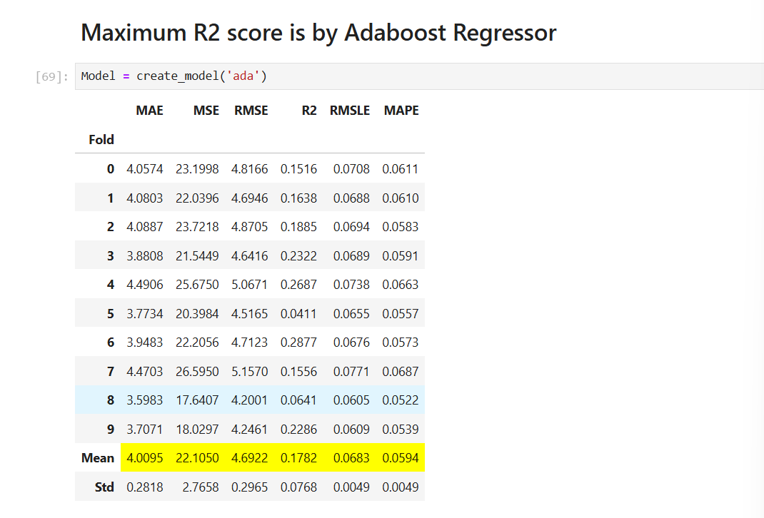

**Drawing insights from Prediction:**

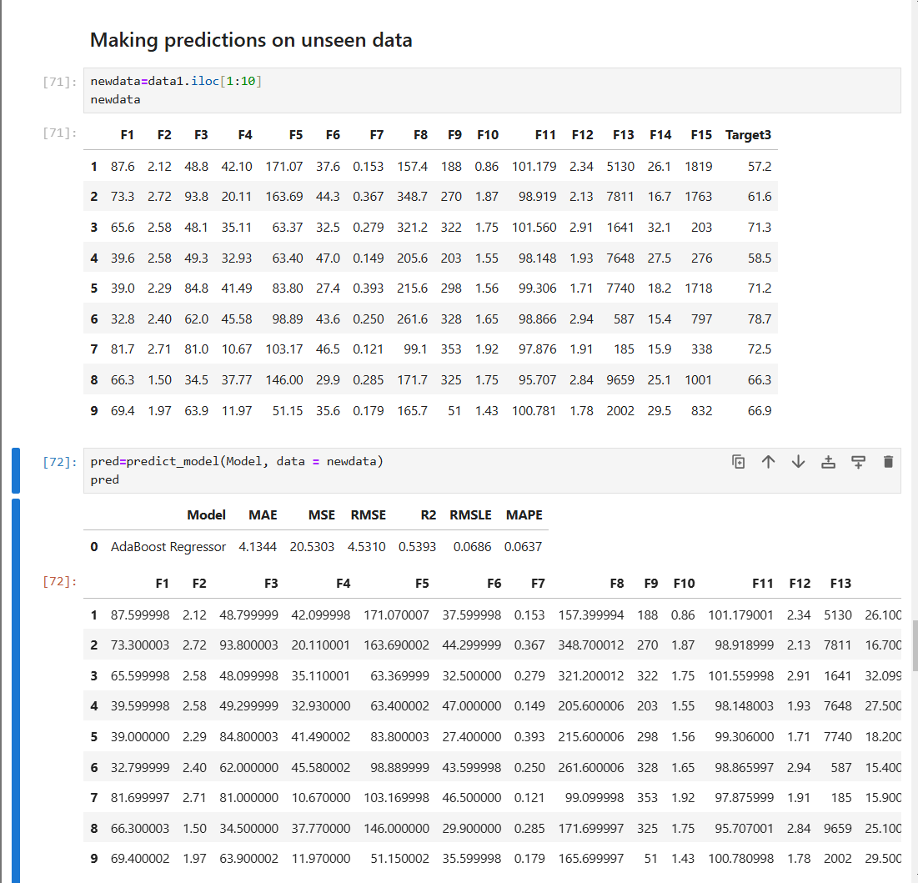

**Data Visualisation:**

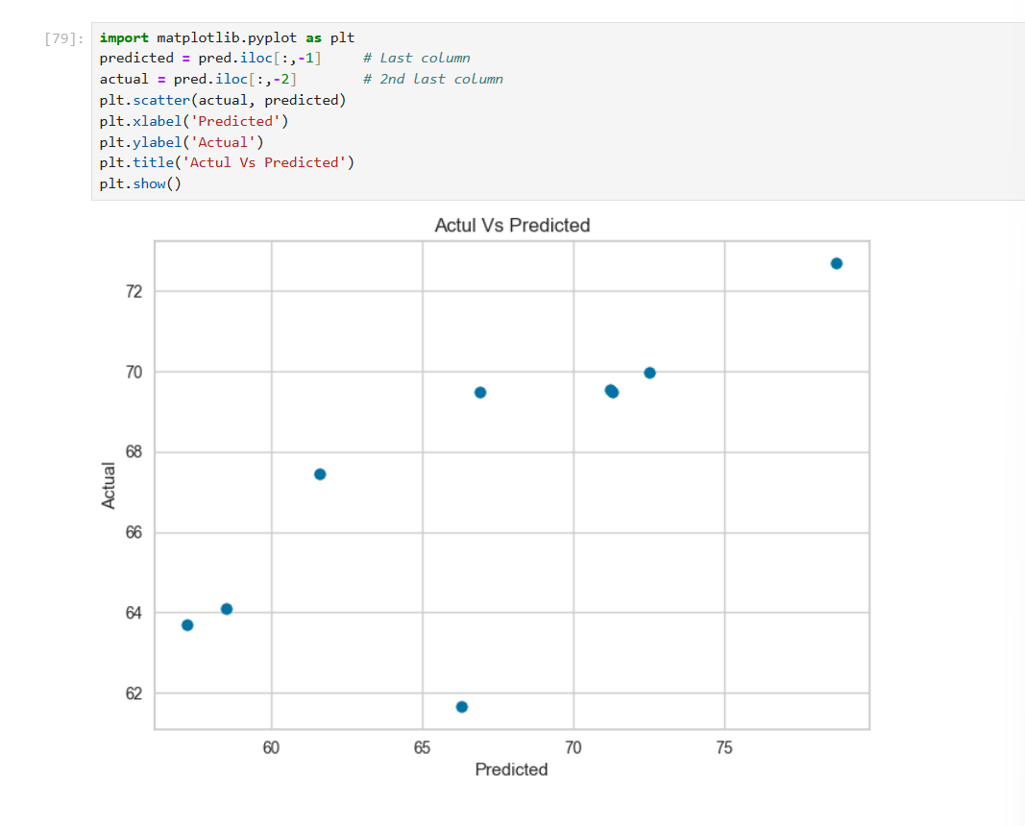

**Plotting the Adaboost Model:**

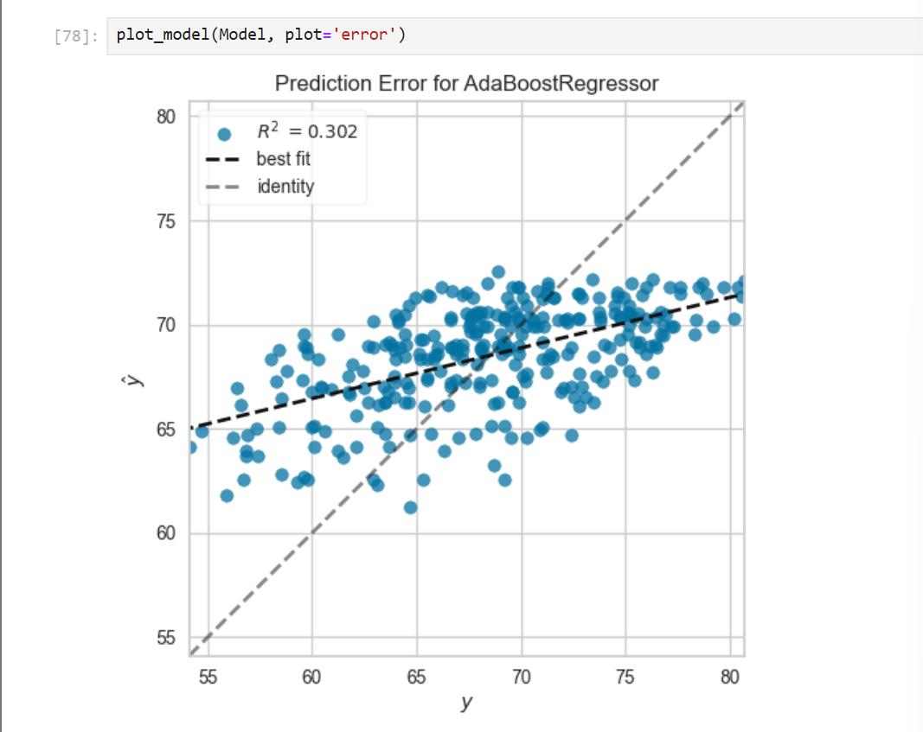

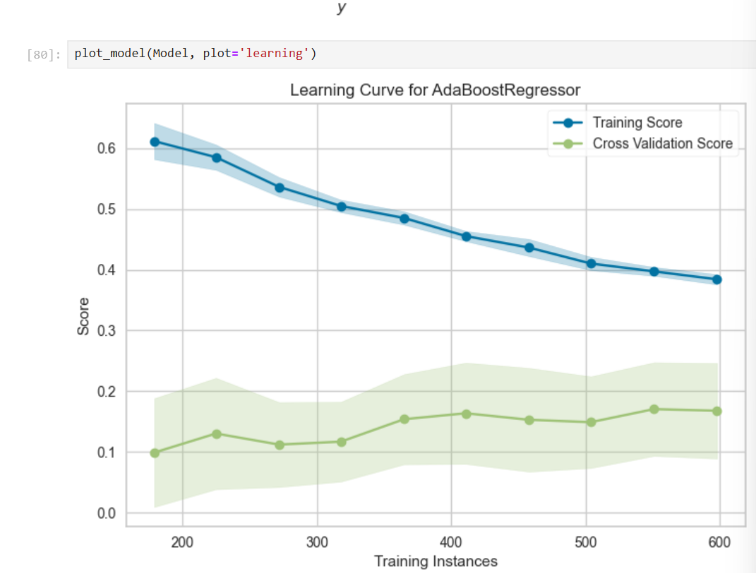

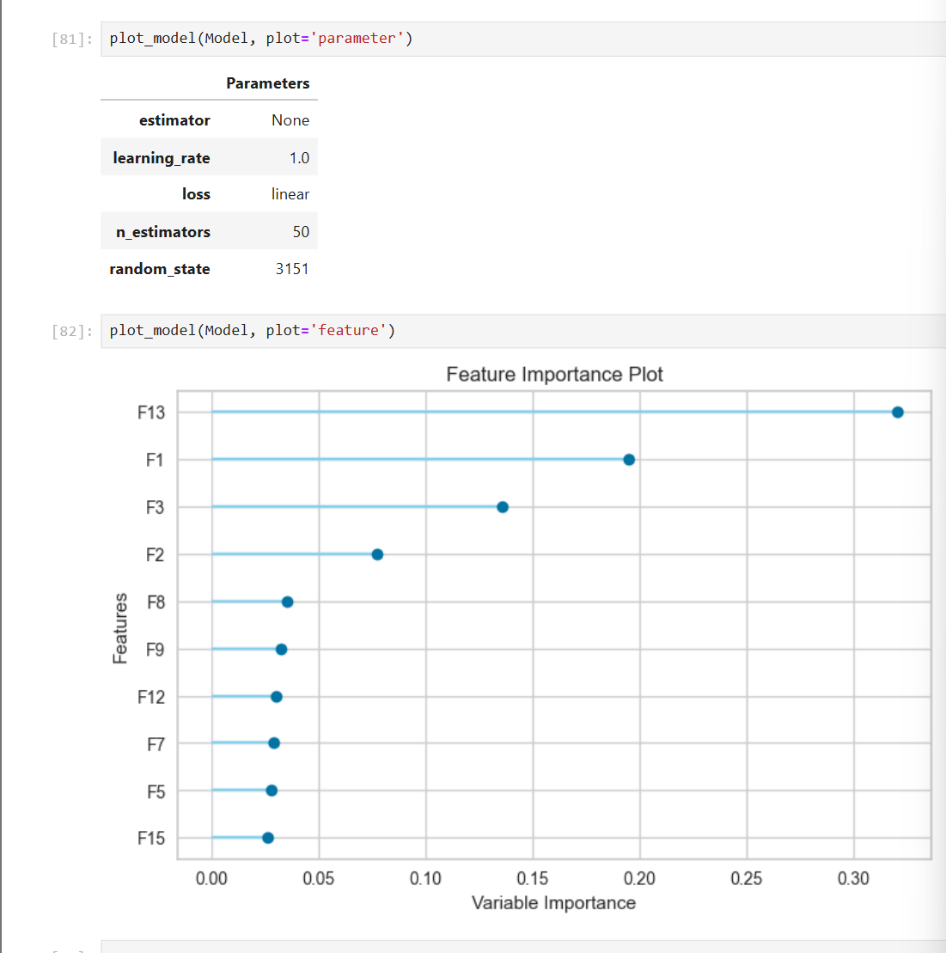

**Conclusions:**

**The analysis reveals that the Adaboost model demonstrated the best performance among the tested models, with an R-squared score of 0.1782. This indicates a modest relationship between the features and the target variable, suggesting potential for further optimization.**